Docker Challenge – Final

# Student Information

Name: Abdulkhaleq Al Shami

Class and Teacher: CPSY300 Operating Systems, Mrs. Rajani Phadtare

Student ID: 000908872

DATE: 2024-04-20

Challenge 3 Steps and guide

1. Our first and main step said by the pdf is to download the challenge3.zip file and extract its content to the main root folder which is titled as “challenge3”.
2. The next step is to read thoroughly the pdf document provided to complete challenge 3 and make sure we are understanding every point in the process.
3. I made the .env file that has the application configuration and database configuration variables.
4. Now, its time to set up the docker-compose.yml file. Making sure that all 3 services are included and connected well with the yml file and in the project.
5. Now, its time for me to make sure I have docker installed and with the latest version on my desktop: go to cmd and write “docker --version”.A black screen with white text

   Description automatically generated
6. Now we need to make sure we have the docker compose downloaded and up to date with the latest version: while in cmd, run docker-compose –version.

1. Now that we have everything up to date: We need to run “docker-compose build” to build the images.
2. While running that command, I have received a error message: 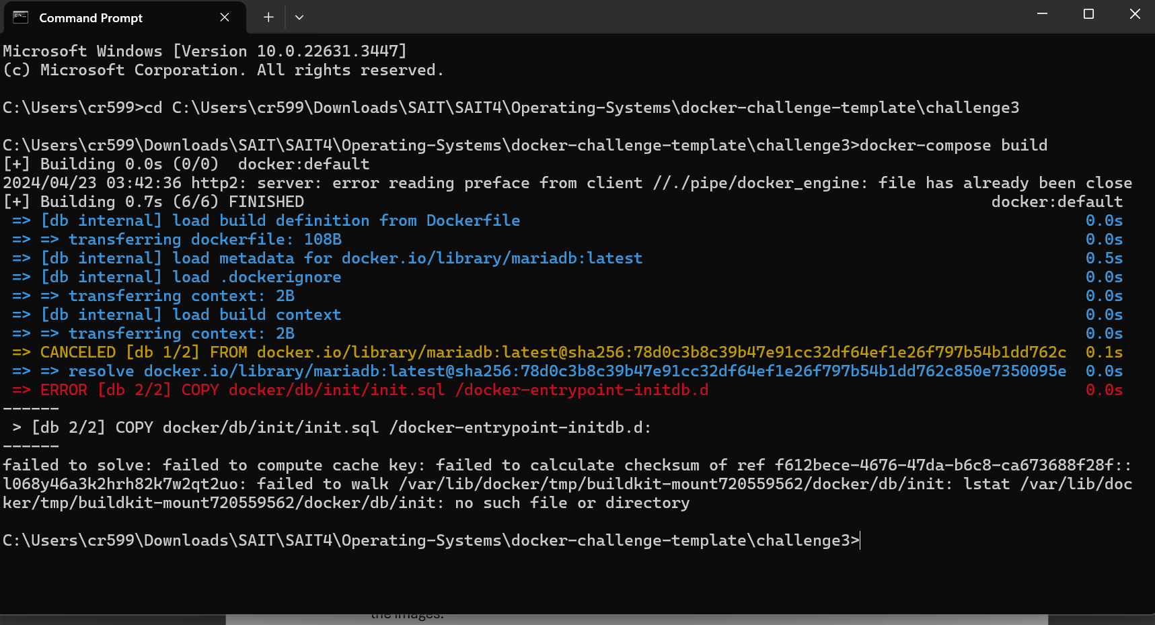
3. In order to fix the problem, we need to change the Dockerfile in the db folder to make sure that the copy path is correct as well as the api Dockerfile: A screen shot of a computer

   Description automatically generated

1. After we ran docker-compose build, I saw 3 new images on the Docker Desktop: A screenshot of a computer

   Description automatically generated
2. After that everything was running correctly and I ran docker-compose up -d to test the containers and to get the servers up.

1. Then I ran, docker-compose ps to check the table information for each service:

1. Finally, I ran <http://localhost:8080/api/books>, and I saw the results using Microsoft Edge: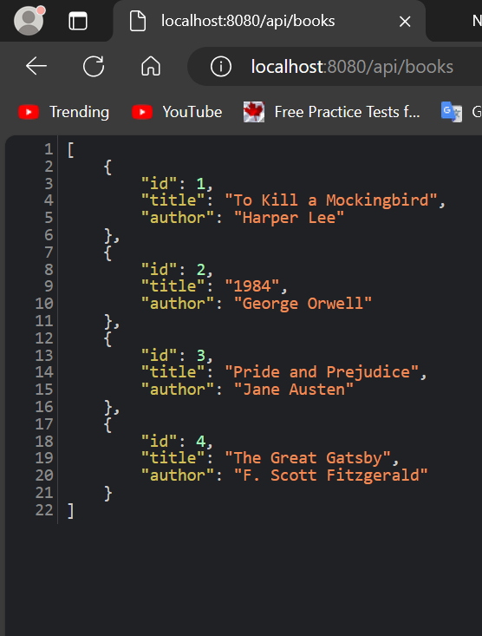
2. Now the challenge 3 is fully complete!

Challenge 4 Steps and Guide

1. In order to start with challenge 4, we need to make sure that the compose from challenge 3 is closed correctly, run: “docker-compose down”, like this: 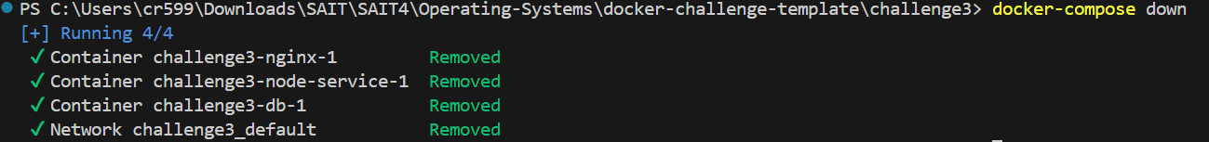
2. Now I need to copy and paste the docker folder, .env file, and the docker-compose.yml file to challenge4.
3. Now that I got the files set up, open terminal and run cd challenge4, then docker-compose build. This should build the servers
4. Now type docker-compose up -d, the same we did for challenge 3: 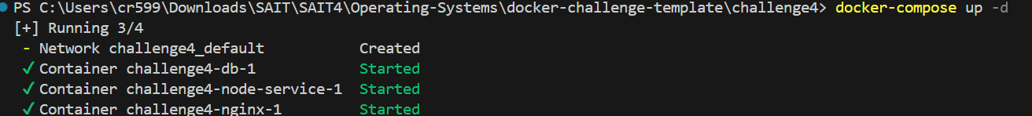
5. Now I went on Microsoft edge and opened the [localhost:8080/api/stats](http://localhost:8080/api/stats) link and it showed me this information and also provided me with the following hostname: 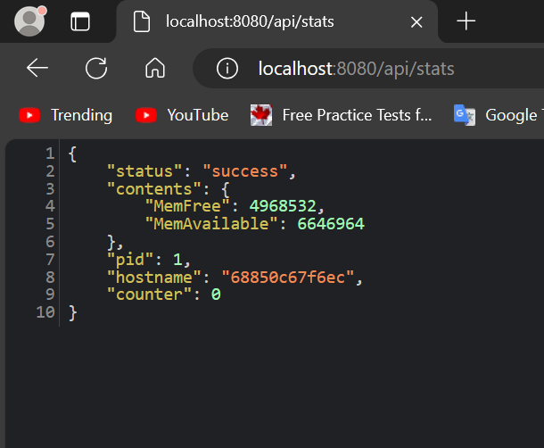
6. Here is the hostname: "hostname": "68850c67f6ec",
7. I have refreshed several times and I am getting the same host name which is correctA computer screen shot of text

   Description automatically generated
8. Now I ran docker-compose down to shut down the host server: 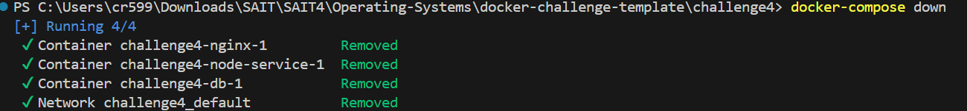
9. After I ran this command: docker-compose up --scale node-service=3 -d, I received an error through the process: 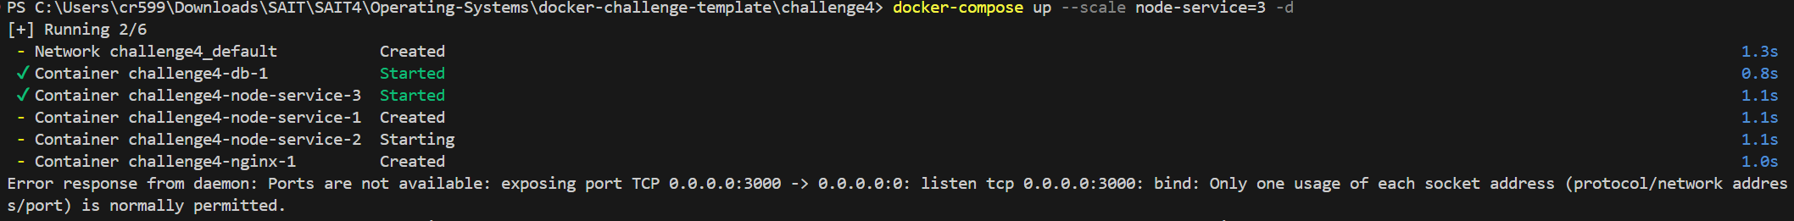
10. In order for me to fix the issue, I had to run docker-compose down again to make sure everything stops running before executing the docker-compose up --scale node-service=3 -d.

1. After modifying the code for docker-compose.yml line 27, it had a “3000:3000” then I modified it to the following and it worked:

1. Now I went on the browser and I saw this these host names

* Number 1: 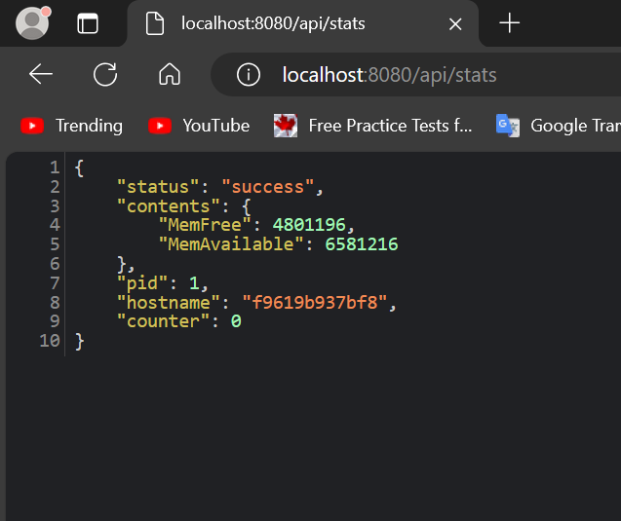
* Number 2: A screenshot of a computer screen

  Description automatically generated
* Number 3: 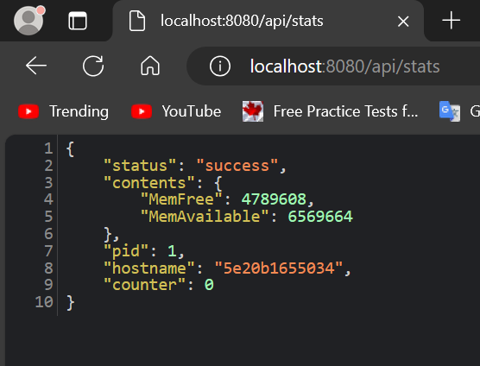

1. Finally, I ran docker-compose ps and I got this result in the terminal: 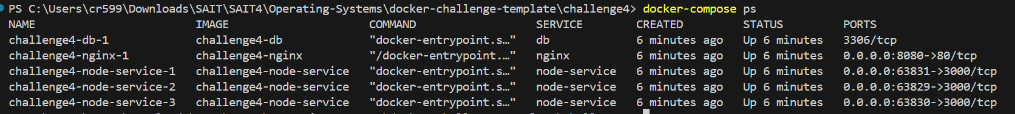

Referencing

1. [1] F. Faboor, and A. aefaef, “How to get number from Docker-compose up --scale,” Stack Overflow, [https://stackoverflow.com/questions/48531626/how-to-get-number-from-docker-compose-up-scale](https://stackoverflow.com/questions/48531626/how-to-get-number-from-docker-compose-up-scale%20) (accessed Apr. 23, 2024).

2. [2] C. CursedChico, et al., “[Docker-compose up, down, stop start difference,” Stack Overflow, https://stackoverflow.com/questions/46428420/docker-compose-up-down-stop-start-difference](Docker-compose%20up,%20down,%20stop%20start%20difference,”%20Stack%20Overflow,%20https:/stackoverflow.com/questions/46428420/docker-compose-up-down-stop-start-difference) (accessed Apr. 23, 2024).

3. [3] “A complete overview of Docker architecture,” Cherry Servers, <https://www.cherryservers.com/blog/a-complete-overview-of-docker-architecture> (accessed Apr. 23, 2024).